Lab Task Five
Database Systems
SQL: DATA DEFINITION LANGUAGE and DATA MANIPULATION LANGUAGE
Objectives
At the end of the lab session the students should be able to: 1. Create database, create, populate, fetch, update and delete tables' record. CRUD
2. Assign Primary or Foreign keys in tables
3. Modify a table definition: Adding/ Dropping columns or constraints.

EXAMPLE:
Convert the ER Diagram below into a database with all constraints put into consideration.

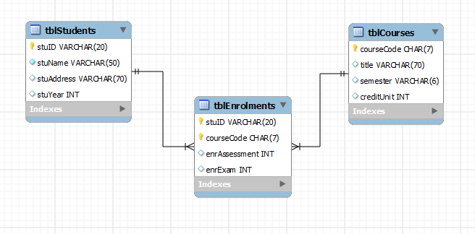

STEPS:
1. Open MySQL Console (Black Window) and you will be prompt for password. Hit on "Enter" to proceed to the root: mysql>
2. Type the command
CREATE DATABASE Examination;
and hit Enter to create the database called Examination.
N.B: SQL commands always ends with a semi colon (;).
Then type:
USE Examination;
and hit "Enter" to select the Examination database.

3. Next is to create database tables: tblStudents, tblEnrolments and tblCourses base on the ER Diagram above.

- To create the table tblStudents type and run:
mysql> CREATE TABLE tblStudents(
stuID VARCHAR(20) NOT NULL,
stuName VARCHAR(50) NOT NULL,
stuAddress VARCHAR(50),
stuYear INT DEFAULT 1,
CONSTRAINT pktblStudents PRIMARY KEY (stuID));

- To create the table tblCourses type and run:
mysql>CREATE TABLE tblCourses(
courseCode CHAR(7) NOT NULL,
title VARCHAR(70) NOT NULL,
semester VARCHAR(6),
creditUnit INT DEFAULT 1,
CONSTRAINT pktblCourses PRIMARY KEY (courseCode));

- To create the table tblEnrolments type and run the command below:
mysql>CREATE TABLE tblEnrolments (
stuID VARCHAR(20) NOT NULL,
courseCode CHAR(7) NOT NULL,
enrAssessment INT,
enrExam INT,
CONSTRAINT enrPK PRIMARY KEY (stuID, courseCode),
CONSTRAINT enrStu FOREIGN KEY (stuID) REFERENCES tblStudents (stuID),
CONSTRAINT enrCou FOREIGN KEY (courseCode) REFERENCES tblCourses (courseCode));

4. To modify the above definition of tblCourses table we can drop the primary key, add a new column (department) and then restore the primary key constraint by running the commands below:

mysql> ALTER TABLE tblCourses DROP PRIMARY KEY courseCode;

/* To view table structure whether key is Dropped*/

mysql>describe tblcourses;

mysql> ALTER TABLE tblCourses ADD COLUMN department VARCHAR(30);

/* To view table structure whether column is added*/

mysql>describe tblcourses;

ALTER TABLE tblCourses ADD CONSTRAINT tblcosPK PRIMARY KEY (courseCode);

/* To view table structure whether key is added*/

mysql>describe tblcourses;

5. Insert 3 Sample records (tuples) into the tables with the commands below:

insert into tblcourses (courseCode, title, semester, creditUnit, department)
values ("COSC309", 'Database Management', 'First', 3, 'Mathematics');

insert into tblcourses (courseCode, title, semester, creditUnit, department)
values ("COSC301", 'Data Structures', 'First', 3, 'Mathematics');

insert into tblcourses (courseCode, title, semester, creditUnit, department)
values ("COSC311", 'Organization of Programming', 'First', 3, 'Mathematics');

Run the Command below to view the courses inserted into tblcourses:

mysql> select * from tblcourses;

To populate the tblStudents table we run the command below for three records at a time:

insert into tblStudents ("U03MT2018",'Alqasim Yusuf','12 Bata, Kano.',2015),
("U02CS2017",'Simon Manasseh','31 Lagos Street, Sabon Gari',2015),
("U04CH2019",'AbdulQadir Abubakar','31 Gyambu Road, Gombe',2015);

Run the two commands below and study their outputs:
mysql> select * from tblStudents;
mysql> select studID, studName from tblStudents;

Task:
- Add three more records of your friends into the database and enroll them into COSC309.
- Try enrolling a student into COSC305. Does it work? If No, why?

Exercise:
Convert the ER Diagram below into a database with all constraints put into consideration.

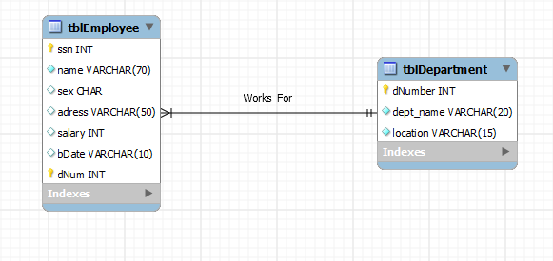
- Populate each table with a minimum of 5 records each.
- Delete a record a record from each table
- Drop the primary key in the department table and add it again.

